**FILDAS: A DIGITAL ARCHIVING SYSTEM FOR THE QUALITY ASSURANCE OFFICE OF FILAMER CHRISTIAN UNIVERSITY, INC.**

A CAPSTONE PROJECT PROPOSAL

Presented to the Faculty

The College of Computer Studies

Filamer Christian University

Roxas City, Capiz, Philippines

In Partial Fulfillment

of the Requirements for

IT 13 - CAPSTONE PROJECT AND RESEARCH I

By

**AQUINO, LOR FREDERICK JAMES R.**

**BANAY, JOSEPH MARIE D.**

**DOLFO, REI ASHLEY**

**EBACUADO, STEFAN JOHN M.**

JANUARY 2026

**TABLE OF CONTENTS**

Title Page i

Table of Contents ii

List of Figures iii

List of Appendices iv

I Introduction

Overview 1

Desired 2

Statement 2

Objectives

General 3

Specific 4

Frameworks

Theoretical 5

Conceptual 6

Operation Definition 8

Scope 9

Significance 10

II Review of Related Literature 12

III Methodology 24

Bibliography 39

**CHAPTER I**

**INTRODUCTION**

*Overview of the Current State of Technology*

Document Management Systems (DMS) are software solutions that store, organize, and control documents across their lifecycle using features such as centralized repositories, version control, audit trails, role-based access control, and notifications (Aliazas, 2024; Gani, 2024; Mushhad, 2009). These capabilities help organizations streamline document handling, reduce manual work, and support compliance with institutional and external quality standards (Mushhad, 2009; Sokoine University of Agriculture, 2022).​

Despite these advantages, many organizations, including Quality Assurance (QA) offices within educational institutions, currently rely on generic cloud storage platforms like Google Drive as their primary method for document management, which is consistent with findings that staff often depend on basic file storage tools before EDMS adoption. While such platforms offer basic file storage and sharing capabilities, they lack many of the specialized features that dedicated DMS solutions provide, particularly advanced metadata, workflow support, and auditability (Capitol University EDMS study, 2017; Aliazas, 2024). This reliance often results in staff manually uploading, organizing, renaming, and verifying files, which is time-consuming and prone to human error, a challenge similarly reported in case studies of paper-based and semi-digital processes in universities. Furthermore, these platforms typically do not support automated notifications of new or updated documents, comprehensive versioning, detailed audit logs, or granular access permissions, which are vital for effective document control in higher education records management.​

However, these limitations are also present in the QA Office of Filamer Christian University, where staff depend on Google Drive and manual handling for QA documents, leading to confusion in file naming, delays in locating records, and limited visibility into who accessed or changed specific documents. This situation demonstrates the need for a centralized and secure digital archiving system like FilDAS to streamline QA document processes and strengthen control over quality-related information, similar to the benefits reported in implemented EDMS projects at universities.

*Desired State of Technology*

The desired state for the QA Office is a centralized and secure digital archiving system that streamlines document handling through structured workflows and intelligent organization. In FilDAS, departmental users submit documents into a standardized document manager where metadata tags enable consistent organizing and faster retrieval. QA staff can review, verify, and archive submissions within the system, reducing processing time and manual effort.

The system enforces clear role-based access, with QA administrators managing approvals, users, and activity logs, while departmental staff access only their own department's documents unless explicitly shared. This structure protects sensitive QA records while enabling collaboration.

FilDAS provides a user-friendly interface with dashboards, status indicators, integrated feedback, and automated notifications for document events and approvals. Unlike generic cloud storage, FilDAS incorporates comprehensive activity logs, version control, structured metadata, and backup mechanisms—directly supporting the objectives to streamline handling, secure sharing, enable faster search, support timely notifications, and establish complete audit trails for accountability and compliance.

*Statement of the Problem*

The Quality Assurance (QA) Office of Filamer Christian University faces inefficiencies in handling and managing documents due to reliance on manual processes, resulting in delays, disorganization, and lack of accountability. Specific Problems:

1. Manual and slow digital handling of documents makes it difficult to ensure accuracy and consistency. Departments use different naming conventions and folder structures, creating confusion and inconsistency.
2. The absence of automated notifications for new or updated documents leads to delayed awareness and poor coordination between departments.
3. Difficulty in sharing documents securely and efficiently among departments, including challenges in handling bulk downloads and uploads, results in miscommunication, duplicated efforts, and risks to document integrity.
4. Difficulty in retrieving and searching for files causes wasted time and reduces staff productivity.
5. The lack of comprehensive audit trails and activity logs undermines accountability and complicates error detection and compliance tracking.

*Objectives of the Study*

*General Objectives:*

To design and develop FilDAS, a centralized and secure digital archiving and document management system for the Quality Assurance Office of Filamer Christian University that streamlines document handling, improves retrieval speed, strengthens access control, enhances coordination through timely notifications, and increases accountability through comprehensive activity logging.

*Specific Objectives:*

1. To streamline the uploading, organizing, and verification of QA documents, reducing manual handling and processing time while improving the accuracy and consistency of stored records.
2. To ensure QA staff and departmental users receive timely notifications about relevant document submissions, updates, approvals, and required actions, thereby improving coordination and reducing delays in QA processes.
3. To provide controlled document sharing using department-based and role-based access permissions, so that QA staff, QA administrators, and departmental staff can collaborate efficiently while protecting sensitive QA information.
4. To enable faster retrieval of QA documents—targeting a reduction in search time from around 10–60 minutes to less than 5 minutes by supporting structured categorization, metadata tagging, and advanced search filters.
5. To record and maintain detailed audit logs of user and document activities, ensuring all document actions are logged and traceable to support accountability, error investigation, and compliance monitoring.

*Theoretical and Conceptual Framework of the Study*

**Figure SEQ Figure \* ARABIC 1. Theoretical Framework of the Study**

*Theoretical Framework of the Study*

**Figure SEQ Figure \* ARABIC 1. Theoretical Framework of the Study**

**Figure 1. Theoretical Framework of the Study**

This study is grounded in the Task-Technology Fit (TTF) theory, which posits that technology adoption and performance impacts depend on how well system capabilities align with user tasks (Goodhue & Thompson, 1995). FilDAS is designed to align with QA office document tasks—uploading, organizing, verifying, retrieving, sharing, and securing documents. By tailoring features like notifications, role-based access control, and audit trails to these specific needs, the system reduces manual workloads, minimizes errors, and facilitates smoother workflows, consistent with TTF’s assertion that better fit improves individual performance. This alignment supports efficient task completion and encourages sustained system use, providing a strong theoretical basis for evaluating FilDAS effectiveness.​

Complementing TTF, the Confidentiality-Integrity-Availability (CIA) Triad provides a security-focused foundation. The CIA Triad emphasizes three core objectives: confidentiality (restricting access to authorized personnel), integrity (preventing unauthorized modifications through audit trails), and availability (ensuring reliable document access). FilDAS addresses these principles through role-based access controls, comprehensive audit logging, and robust backup mechanisms, making it essential for protecting sensitive QA information and maintaining institutional compliance, as recommended in information security guidance for organizations.​

Additionally, the Technology Acceptance Model (TAM) explains how perceived ease of use and perceived usefulness drive user adoption (Davis, 1989). FilDAS maximizes both through an intuitive interface, streamlined workflows, and clear feedback, promoting acceptance and long-term adoption by QA staff and departmental users, in line with TAM-based studies on EDMS in higher education. Together, these three frameworks provide a comprehensive theoretical foundation for designing and evaluating a practical, secure, and user-centered DMS

*Conceptual Framework of the Study*

**Figure SEQ Figure \* ARABIC 1. Theoretical Framework of the Study**

The conceptual framework for the FilDAS Document Management System (DMS) serves as a structured visualization of how the system addresses the core document management challenges faced by the Quality Assurance (QA) Office at Filamer Christian University. It maps out the relationships between four user roles, system modules, and a centralized database, underscoring the project's alignment with 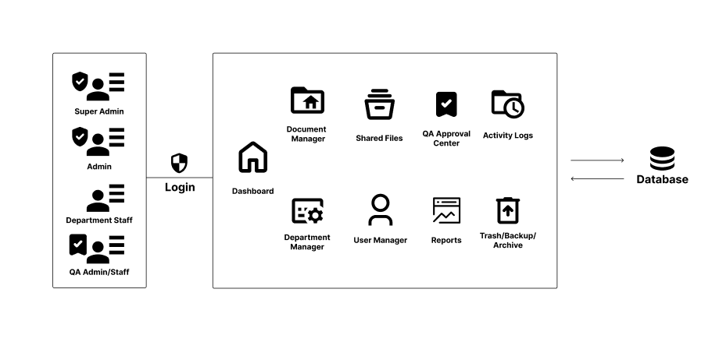principles of security, efficiency, and compliance.

**Figure 2. Conceptual Framework of the Study**

*User Roles and Access Structure*

As depicted in Figure 2, the framework distinguishes four main user roles, each with distinct page access, action permissions, and data visibility levels:

Super Admin

* Grants comprehensive access across all system modules and departments
* Can access all pages: Dashboard, Document Manager (all departments), Shared Files, QA Approval Center, Activity Logs, User Manager, Department Manager, Reports, Trash/Backup/Archive
* Actions: Upload, edit, move, delete, and restore documents across all departments; manage folders globally; share any document or folder; view all activity logs
* Data visibility: Can see all rows in documents, folders, activities, and shares across the entire system

Admin (Department-level)

* Provides department-specific administrative functions
* Can access Document Manager for their own department, Trash for their own department, and Shared Files sent to them
* Actions: Upload, edit, move, delete, and restore documents within their own department; manage folders within their department; share documents and folders within their department; view activity logs specific to their department
* Data visibility: Can see documents and folders where department_id matches their own; can see activities and shares connected to those items

QA (Quality Assurance Staff)

* Enables specialized review and approval functions across assigned documents
* Can access Document Manager (for QA and assigned departments), QA Approval Center, Shared Files, Activity Logs, and Reports
* Actions: Review and change document status (approve/reject) for assigned documents; provide comments on documents under review; view documents shared to QA or in QA-assigned departments; cannot delete documents
* Data visibility: Can see documents assigned to them, documents in QA-marked departments, and documents shared directly to them; can access activity logs and reports for these documents

Department Staff

* Provides standard user functionality for document submission and collaboration
* Can access Document Manager for their own department and Shared Files sent to them
* Actions: Upload documents into their own department; edit only documents they have uploaded or own; view documents shared directly to them; cannot approve, reject, or delete documents (except their own unsent drafts); cannot access trash, admin tools, or global activity logs
* Data visibility: Can see documents they uploaded or own, approved documents in their department, and documents explicitly shared to them

System Modules and Database Integration

Both user types interact with a centralized database, which functions as the repository for all documents, metadata, and system activities. The framework connects users and modules to this shared database through secure login and role-based permission enforcement at both the page-access level and the database-query level.

Core Modules include:

* Dashboard: Overview and status indicators for relevant documents and tasks
* Document Manager: Central hub for uploading, organizing, categorizing, and managing documents within department scope
* Shared Files: Display documents explicitly shared to the user from other departments or administrators
* QA Approval Center: Dedicated interface for QA staff to review, comment, approve, or reject documents
* Activity Logs: Comprehensive record of all user actions, document changes, and system events (filtered by user role)
* User Manager: Administration of user accounts and role assignments (Super Admin only)
* Department Manager: Administration of departments and department-level settings (Super Admin and Admin only)
* Reports: System-generated reports on document metrics, workflows, and compliance (filtered by user role)
* Trash/Backup/Archive: Recovery and backup management of deleted documents (role-dependent access)

This architecture supports real-time document tracking, robust version control, comprehensive audit trails, structured metadata management, and secure data backups across all departments.

*Operationalization of Theoretical Frameworks*

By connecting users and modules to the shared database through role-based access control at both page and database levels, the framework operationalizes the integration of Task-Technology Fit, Confidentiality-Integrity-Availability (CIA) Triad, and Technology Acceptance Model (TAM) principles:

* Task-Technology Fit: The role-specific page access and action permissions ensure that each user type sees and can perform only the tasks necessary for their role, reducing cognitive overload and improving efficiency.
* CIA Triad: Role-based access control enforces confidentiality by restricting data visibility to authorized personnel; activity logs ensure integrity by tracking all modifications; and system redundancy with backup/archive functions maintain availability.
* Technology Acceptance Model: The intuitive module layout, role-appropriate dashboards, and streamlined workflows enhance perceived ease of use, while role-specific features increase perceived usefulness for each user group.

The resulting architecture enables the QA office to transition from a fragmented, manual document process to a secure, efficient, and fully auditable digital environment. The DMS not only streamlines document workflows and departmental coordination but also strengthens accountability, user productivity, and the overall quality assurance function of the office.

*Operational Definition of Terms*

Accreditation  
The formal process of institutional evaluation by external bodies to verify that an educational organization meets established quality standards and requirements.

Approval Workflow  
A structured process within the system where documents move through defined stages of review and authorization before being finalized or archived.

Audit Log  
A detailed record maintained by the system that documents all user actions, access attempts, and document modifications with timestamps and user identification for accountability and security purposes.

Audit Trail  
A record of all document actions to ensure transparency and accountability.

Backup and Recovery  
System mechanisms that create copies of critical data and documents to protect against data loss and enable restoration of information in case of system failure or emergency.

Centralized Repository  
A single, unified storage location where all documents and records are consolidated, organized, and managed rather than scattered across multiple locations or platforms.

Compliance  
Adherence to institutional policies, legal requirements, and established standards and regulations that govern document management and quality assurance operations.

Data Integrity  
The assurance that documents and records remain accurate, complete, and unaltered except through authorized modifications tracked in the system.

Department Administrator  
A user role responsible for managing document submissions and approvals for a specific academic or administrative department or college within the university.

Digital Archiving  
The process of systematically storing, organizing, and preserving electronic documents in a secure, long-term repository for future retrieval and compliance purposes.

Document Management System (DMS)  
Software that stores, organizes, tracks, and manages electronic documents to improve efficiency and security.

Electronic Document  
Any information stored in digital format, including Word files, PDF documents, spreadsheets, presentations, and other digital files managed within the system.

File Naming Convention  
Standardized rules and protocols for naming documents consistently across the system to improve organization, searchability, and identification of documents.

ISO 21001:2025  
An international management system standard designed for educational organizations to enhance their quality, effectiveness, and continuous improvement in educational services.

Metadata Tagging  
Adding descriptive tags to documents for easier search and organization.

Notification Module  
A system feature that alerts users of new or updated documents automatically.

QA Compliance Documents  
Records and reports required by the Quality Assurance office to verify institutional adherence to quality standards, including evaluation reports, monitoring records, and policy documentation.

Quality Assurance (QA)  
The process to ensure documents are accurate, organized, and meet quality standards in the QA office.

Role-Based Access Control (RBAC)  
A system that limits access to documents based on user roles to protect sensitive information.

System Security  
The collection of technical and procedural measures implemented to protect documents, user information, and system functionality from unauthorized access, modification, or loss.

User Authentication  
The process of verifying user identity through credentials such as username and password before granting access to the FilDAS system.

User Role  
A defined position or responsibility level within the system that determines what functions a user can perform, what documents they can access, and what actions they can take.

Version Control  
The system's ability to maintain multiple versions of documents, track changes, identify the most current version, and provide access to previous versions when needed.

Web-Based System  
Software application accessed through internet browsers, allowing users to interact with the FilDAS system from any location with internet connectivity without requiring local installation.

Workflow Bottlenecks  
Delays and inefficiencies caused by manual document management tasks.

*Scope and Limitations of the Study*

This study focuses primarily on the Quality Assurance (QA) office staff of Filamer Christian University as the main user group, with supplementary input from selected staff in other university departments who upload or interact with QA documents.

*Scope*

The system will specifically handle QA compliance documents such as accreditation reports, quality monitoring documents, institutional policy records, and program evaluation files but will not cover student academic records, payroll information, or other sensitive non-QA institutional documents. The study evaluates the proposed web-based FilDAS against the current Google Drive-based manual system across six key evaluation criteria: system quality (usability, functionality, reliability), information quality (document organization, searchability, metadata accuracy), service quality (system performance, support), user acceptance and satisfaction, usage patterns and adoption rates, and security measures (access control, audit trails, data protection). The system is being designed to align with ISO 21001:2025 standards by providing transparent, accessible, and reliable document management processes that support the QA office in ensuring compliance and continuous improvement. System components include user authentication, document management with version control, role-based access control, notification systems, audit logging, document search and retrieval, and data backup mechanisms.

*Limitations*

Limitations of the system and study include the following:

(1) Scope limitations—the project is conducted and evaluated within a single university's QA office, so findings cannot be generalized to other educational institutions or organizations with different document management needs or organizational structures;

(2) User sample—the study population is limited to available QA office staff and selected departmental representatives from Filamer Christian University, which may restrict the diversity of perspectives and insights gathered;

(3) Timeframe—the study covers only the initial development and implementation period and does not assess long-term impacts across multiple academic years, limiting conclusions about sustained user adoption and extended system effectiveness;

(4) Technical constraints—the system requires reliable internet connectivity and compatible web browsers; users may need additional hardware or software upgrades to fully utilize all features;

(5) User training and adoption—the success of FilDAS depends on adequate user training and organizational commitment; this study does not guarantee full institutional adoption or the organizational changes needed for long-term system success;

(6) ISO 21001:2025 compliance—although FilDAS is designed following ISO 21001:2025 guidelines to support document transparency and accessibility, full institutional certification and compliance are beyond the scope of this project and would require comprehensive institutional audits, formal policy implementation, and extended organizational commitment;

(7) Data collection—research findings depend on available user feedback and voluntary participation, which may introduce response bias in perceptions of system quality, usefulness, and satisfaction;

(8) Security and backup—while the system includes backup mechanisms within its scope, this study does not test disaster recovery procedures or long-term data preservation under extreme conditions;

(9) Response bias—user responses and perceptions may be influenced by the novelty of the system or researcher presence, potentially affecting the objectivity of findings regarding user acceptance and satisfaction.

**CHAPTER II**

**REVIEW OF LITERATURE AND STUDIES**

***Overview***

*Summary of Related Literature*

Document Management Systems (DMS) have become essential tools across diverse sectors, including education, government, and business, to effectively manage the growing volume of documents. The evolution from manual, paper-based filing to digital, web-based platforms has resulted in significant improvements in document retrieval speed, secure storage, workflow automation, and operational efficiency. Recent studies demonstrate that web-based DMS implementations yield high user satisfaction, enhanced productivity, improved accuracy, and reduced operational costs.

Key features highlighted across the literature include role-based access control, integration of metadata standards, compliance with international standards (e.g., ISO), and the incorporation of emerging technologies such as barcode scanning, email/SMS notifications, and mobile accessibility. Security and confidentiality remain central concerns, with systems incorporating frameworks to protect sensitive data and ensure controlled access.

In educational institutions, DMS support critical functions such as academic record management, faculty evaluations, quality assurance, and accreditation processes, facilitating transparency and continuous improvement. Likewise, government and social welfare agencies benefit from streamlined document tracking and improved inter-departmental communication.

While technology plays a pivotal role, successful adoption also depends on factors beyond the system itself, including organizational culture, user training, stakeholder engagement, and collaborative development approaches. Challenges reported involve managing change, system scalability, technical complexities, and aligning system functionalities with diverse user requirements.

Despite these advances, there are still gaps in scaling DMS implementations beyond institutional levels, conducting long-term impact assessments, and exploring integration with mobile platforms and advanced analytics. Addressing these gaps is critical for future research to develop more comprehensive and adaptive document management solutions.

*Design and Implementation of a Web-based Document Management System (Alade, 2023)*

This study developed a web-based electronic document management system using OOHDM and standard web technologies to digitize organizational documents. It reported high user satisfaction (96.60%), accuracy (95%), and usability (99.20%), demonstrating improved productivity and data efficiency over paper-based methods.

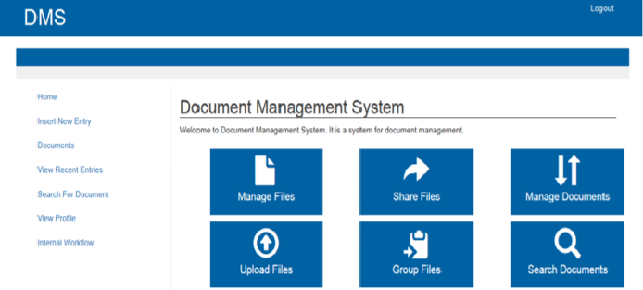The home page as shown in Fig. #3 is the first page that a user sees after logging

**Figure 3. home page**

in to the system. It serves as the main page that directs users to other pages in the system. According to the dashboard displayed on the page, there are four sections on the form: insert new entry, create a new document, view recent document and search for document

*Document Management System for Guangdong Vocational College (Zeng, 2024)*

Focusing on an educational institution, this study developed a network-based DMS that integrated personnel management and file handling. It complied with ISO software standards and optimized system performance using caching and indexing. The DMS improved document accuracy and office efficiency, addressing security and collaboration challenges.

As depicted in Figure #4, the main functional modules of the document management system are displayed in the left navigation bar. Users can utilize this

menu 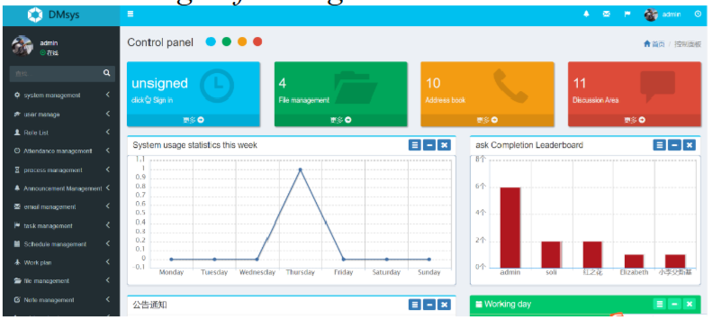

**Figure 4. DMS Modules**

to access relevant operational information through the corresponding modules. Different personnel are granted varying levels of operational upon login, with administrators possessing the highest authority to configure permissions for each account.

*Electronic Archive Management System: A Case Study in University of Basrah, Iraq (Badran & Hamoud, 2024)*

This study presents a web-based Electronic Archive Management System developed for the University of Basrah to replace inefficient, paper-based employee file management. The system allows university employees and administrators to upload, store, and retrieve academic and administrative documents easily. It improves accuracy, reduces resource use, and speeds up data retrieval while supporting annual evaluations and statistical reporting. Challenges during development were managed with collaborative tools. Future plans include features for lecture uploads, student-professor communication, mobile apps, and tools to track teaching progress. The system enhances university employee record management and administrative efficiency.

The file upload page is used to upload files of various types such as images, Word documents, Excel spreadsheets, PDFs, and others. This page includes a list to select employees mentioned in the file, such as acknowledgment letters, and other fields for uploading the file itself, specifying its type, providing details, and entering the date. 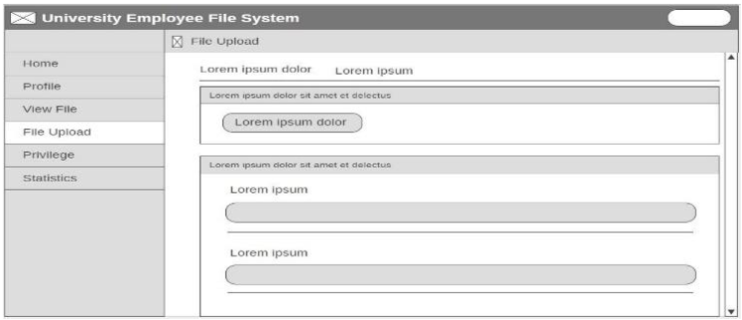as shown in figure #5

**Figure 5. File Upload Page**

*Web-based Document Management System for Pagadian City Office (Nagrama et al., 2024)*

The research developed a web-based system to replace manual document processes across elementary schools and an executive office. Employing the Waterfall model and multiple web technologies, it achieved high ratings in usability, reliability, and security, facilitating streamlined document submission and access.

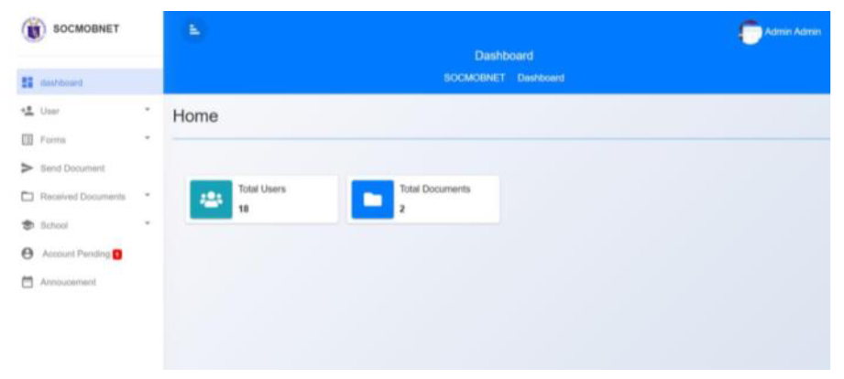Figure #6 shows the interface of the main dashboard on the Administrator’s level

**Figure 6. Main Dashboard Interface**

where the concerned pertinent documents may be distributed to the schools within the locality through the School Principals who will download the documents and upload it back

*Electronic Document Management System for LAN-Based Organizations (Gamido et al., 2023)*

This study created an EDMS operating within a local area network, improving document indexing, storage, and retrieval. Using RAD methodology, it demonstrated high user satisfaction and operational efficiency, securing confidential documents and 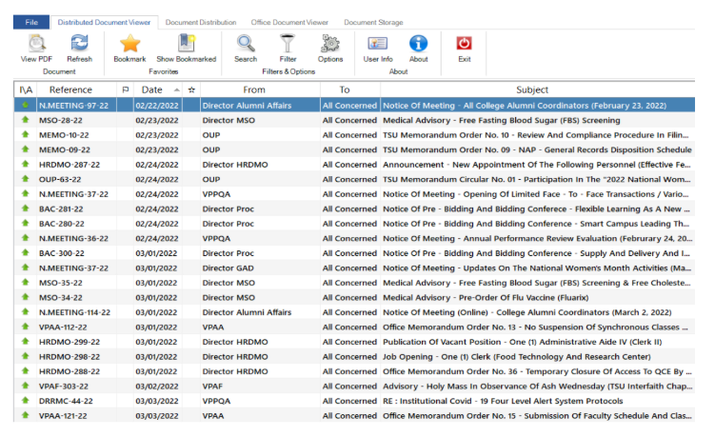facilitating compliance with organizational policies.

**Figure 7. Dashboard Document Viewer**

The distributed document viewer module in the EDMS, as shown in Figure 8, provides a list of all uploaded documents for viewing by recipients. Access to the documents depends on both the user's confidentiality clearance and the distribution of the records office. Only users with a higher confidentiality clearance can view documents marked with high confidentiality levels. Only users assigned to the specific office that was tagged in the distribution of the records office can view the document in the list. To view a document, the user can double-click or right-click the selected document. The distributed document viewer also offers features such as bookmarking favorite documents, sorting documents in ascending or descending order, searching, and filtering documents.

*Development and Implementation of Document Management System for Ilocos Sur Polytechnic State College, Tagudin Campus (Angala et al., 2022)*

This study developed and implemented a web-based Document Management System (DMS) for Ilocos Sur Polytechnic State College (ISPSC) Tagudin Campus to address challenges in managing the increasing volume of paper documents. Despite growing digital trends, many institutions still rely on physical documents, leading to storage issues, difficult retrieval, and high operational costs. The DMS provides a centralized platform to capture, store, organize, and retrieve documents efficiently.

Using a standardized satisfaction survey (WAMMI) with 40 users, results showed strong user satisfaction regarding the system’s ability to arrange, track, and manage files. The study highlights the importance of adopting digital document management in educational institutions to improve workflow, protect information, and support organizational growth, especially as ISPSC transitions into a university with more campuses and users.

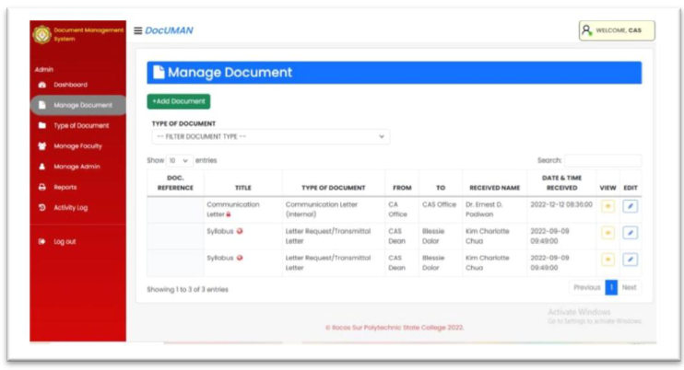

**Figure 8. DocUMAN Manage Document Page**

Figure #8 shows the add document button to upload new documents. The file’s metadata follows the Document Information Registry form maintained by the institution in accordance to ISO 9001.

*Record Management System with Document Control (Pagayonan, 2021)*

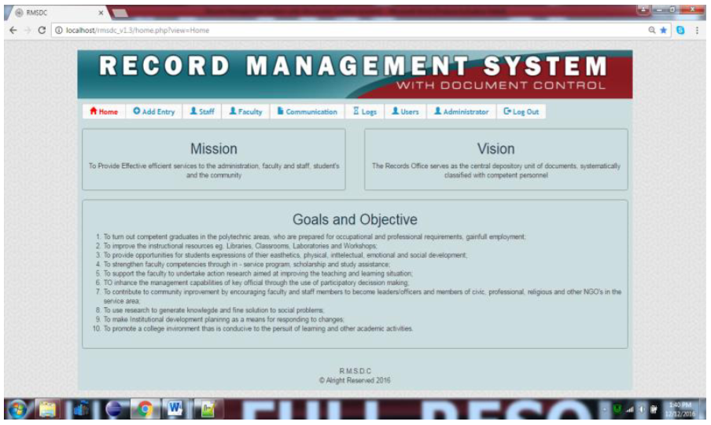This study developed a web-based Record Management System with Document Control for Northern Iloilo Polytechnic State College (NIPSC) to digitize the handling of incoming/outgoing communications, employee leave applications, and human

**Figure 9. Record Management System with Document Control main page**

resource records. The manual paper-based processes caused delays and inefficiencies, particularly in retrieving records and calculating leave credits. Using surveys from 165 respondents and the ISO/IEC 9126 quality model, the system’s usability, functionality, and performance were all rated “Very Good.” The system simplified document receipt and release, streamlined leave monitoring, and improved access to employee records, resulting in reliable, time-efficient services that met user expectations. Figure #9 shows the Record Management System with Document Control main page.

*Web-Based Electronic Document Tracking Management System (Jaquilmo & Sarmiento, 2023)*

This study developed a web-based Electronic Document Tracking Management System for the Department of Social Welfare and Development (DSWD) Field Office V to address the inefficiencies of their manual, log-book-based document tracking. The existing system caused delays, misplaced files, and missed deadlines due to difficulty in locating and managing documents. The proposed system improves document handling by enabling classification, secure storage, retrieval, tracking, and preservation, enhancing communication and workflow efficiency.

The system features barcode scanning, email and SMS notifications, and role-based user access for streamlined document creation, approval, forwarding, and archiving. Its evaluation by IT experts and users showed high ratings in functionality, reliability, usability, efficiency, maintainability, and portability. Users found the interface user-friendly and the system effective in reducing manual processes and improving document monitoring. The study concludes that this electronic document tracking system offers a more efficient, reliable, and accessible solution for managing document flow in the DSWD Field Office V.

*Synthesis and Commentary of Related Literature*

The reviewed studies collectively affirm the critical need for transitioning from traditional paper-based document handling to digital document management systems (DMS) across various organizational settings, including educational institutions, government agencies, and local offices.

Most studies, such as those by Alade (2023), Zeng (2024), and Angala et al. (2022), focused on creating web-based DMS platforms that streamline document capture, storage, retrieval, and management. These systems significantly improve productivity, accuracy, and ease of access compared to manual filing, as demonstrated by high user satisfaction and usability ratings consistently reported (e.g., above 90% in Alade, 96.6% satisfaction). These platforms often conform to international standards (ISO compliance in Zeng, metadata standards in Angala et al.) which enhance their reliability and facilitate institutional integration.

Several projects uniquely emphasized specialized functionalities to fit their organizational contexts. For example, Badran and Hamoud’s (2024) system tailored to university archives supports academic evaluations and statistical reporting, while Pagayonan’s (2021) system integrates leave management with record control, addressing specific administrative workflows. Meanwhile, Jaquilmo and Sarmiento (2023) enhanced document tracking through barcode scanning, SMS, and email notifications to support government office operations, indicative of a trend towards incorporating emerging technologies for comprehensive workflow management.

The reviewed systems also demonstrate improved control over document security and confidentiality, a critical feature underscored in Gamido et al. (2023), which employs user-level confidentiality clearances within a local network environment. Similarly, Zeng (2024) addressed collaboration and security issues particularly relevant for large educational institutions.

Common challenges discussed include managing user access rights, system scalability, and ensuring seamless usability, which many studies tackled through modular design and role-based permissions (e.g., Zeng, Jaquilmo & Sarmiento). Additionally, collaborative development approaches, such as the use of Git in Badran and Hamoud (2024), highlight best practices for managing complexities during system implementation.

A recurring limitation across these studies is the primarily institutional or campus-limited deployment, with most systems not yet scaled to regional or national levels. Furthermore, while user satisfaction and technical functionality are generally well-assessed, long-term impact studies on organizational efficiency and cost savings remain sparse.

In conclusion, the literature underscores an evolving ecosystem of web-based and networked document management solutions tailored to diverse settings but grounded on core functionalities of digitization, accessibility, and control. Future research may explore more integrated, cross-institutional systems, mobile platform expansion, and advanced analytics for document usage and workflow optimization as suggested by prospective features in Badran and Hamoud (2024) and others.

|  |  |  |  |  |  |  |
| --- | --- | --- | --- | --- | --- | --- |
| Study/Features | RBAC | Core Document Lifecycle Management | Metadata Tagging, Search, and Filtering | Hierarchical Folder Organization | Audit Logging and Activity Monitoring | Granular Sharing and Access Control |
| System #1 | ✔ | ✔ | ✔ |  | ✔ |  |
| System #2 | ✔ | ✔ | ✔ |  |  | ✔ |
| System #3 | ✔ |  | ✔ |  |  |  |
| System #4 |  |  |  |  |  |  |
| System #5 | ✔ |  | ✔ |  | ✔ | ✔ |
| System #6 |  |  | ✔ |  |  |  |
| System #7 |  |  |  |  |  |  |
| System #8 | ✔ |  | ✔ |  | ✔ |  |
| FilDAS | ✔ | ✔ | ✔ | ✔ | ✔ | ✔ |

**Table 1. List of Related Studies and Features**

**CHAPTER III**

**METHODOLOGY**

This chapter presents the research methods, procedures, and tools used in the design, development, and evaluation of FilDAS for the Quality Assurance office of Filamer Christian University. It outlines the research design, system development framework, data collection strategies, and evaluation metrics guiding the study.

*Research Design*

The study employs a combination of developmental and descriptive research designs. The descriptive aspect involves identifying and analyzing the current document management challenges faced by the QA office, while the developmental design facilitates the systematic creation, implementation, and evaluation of FilDAS. The integration of these designs ensures a comprehensive understanding of the problem and supports the creation of an effective, user-centered solution.

*System Development Methodology*

FilDAS was developed using a Lean-Agile methodology adapted to the practical constraints of solo development with compressed project timelines. This approach balanced the core Agile principles of iterative development, continuous feedback, and working software delivery with the practical realities of limited development resources and accelerated deadlines.

*Rationale for Methodology Selection*

Traditional Agile methodologies rely on cross-functional teams meeting in multi-week sprints with distributed responsibilities (frontend, backend, testing, deployment). However, this project faced significant constraints:

1. Solo Development Execution: The primary developer assumed all technical roles—frontend development, backend engineering, database design, testing, documentation, and system deployment—requiring a methodology that could accommodate these dual responsibilities without creating bottlenecks.
2. Compressed Timeline: After the thesis proposal defense and feedback stage, a critical deadline acceleration necessitated a more streamlined approach than traditional time-boxed sprints would allow.
3. Limited Testing Resources: With no dedicated QA team available, traditional user acceptance testing phases had to be redesigned using alternative validation methods.

Given these constraints, Lean-Agile methodology was selected because it:

* Prioritizes working software and rapid value delivery over rigid processes
* Emphasizes continuous adaptation and learning
* Reduces waste in development cycles
* Accommodates solo or small-team execution models

*Development Framework: Continuous Iterative Cycles*

Rather than implementing formal two-week or four-week sprints, development proceeded through daily iterative cycles that combined practices from Rapid Application Development (RAD) and Extreme Programming (XP):

Daily Cycle Structure:

* Planning Phase: Each morning, priorities were established based on system requirements, identified bottlenecks, and immediate needs derived from a dynamic backlog.
* Development Phase: Features and fixes were coded iteratively, with continuous attention to code quality and architectural coherence.
* Build and Validation Phase: Code was tested through unit tests, integration tests, and immediate system validation, preventing the accumulation of defects.
* Integration Phase: All new code was integrated into the main codebase daily, maintaining a stable, deployable system state throughout development.

This daily cycle ensured that code quality and system stability were maintained continuously rather than discovered in large batches at the end of sprints. The approach eliminated risks associated with large-batch development (where multiple features developed in parallel create integration conflicts) and provided immediate feedback for course correction.

*Development Tools and Technology Stack*

Frontend Development:

* React with TypeScript: Selected for component-based architecture and type safety, enabling rapid prototyping with fewer runtime errors.
* Tailwind CSS: Utility-first CSS framework for rapid UI development aligned with established user-centered design best practices.

Backend Development:

* Laravel PHP Framework: Chosen for rapid development, built-in security features, and extensive ecosystem for database management and API development.

Database Management:

* MySQL: Relational database system providing robust data management, ACID compliance, and secure storage for sensitive QA documents.

*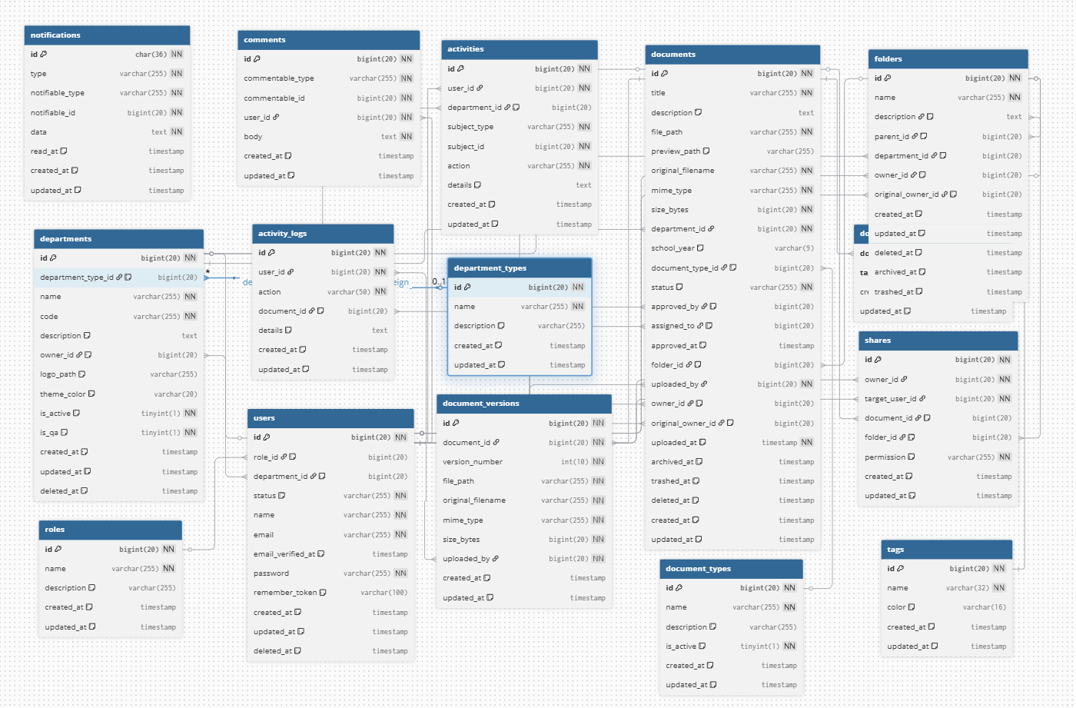Database Schema Design*   
The FilDAS database schema represents the logical and physical data   
organization supporting the system's core functions. The schema is   
structured around the following primary entities:   
  
*Database Integrity:*

**Figure 10. FilDAS Database Schema**

The schema enforces referential integrity through foreign key   
relationships, ensuring consistency between documents, users,   
departments, and access control. This supports the CIA Triad   
principles by maintaining data integrity through constraint-based   
validation.

*AI-Assisted Development as Engineering Tool*

A significant methodological innovation was the strategic use of AI-assisted pair programming to compensate for resource constraints while maintaining development velocity and code quality. The AI assistant functioned as an engineering partner rather than a replacement for human judgment, handling tasks such as:

Code Generation and Debugging:

* Rapid generation of boilerplate code and module structures to accelerate development.
* Assistance in identifying and resolving complex bugs through systematic problem analysis.
* Refactoring suggestions to improve code maintainability and reduce technical debt.

Test Case Design:

* Automated generation of unit test scenarios covering edge cases and common failure points.
* Integration test design to validate API endpoints and data flow between system components.
* Test execution and result analysis, with human review of all results.

Documentation Support:

* Assistance in maintaining system documentation in parallel with code development, ensuring alignment between implementation and specifications.
* Generation of API documentation and user interface documentation.

Methodology Justification: This approach is analogous to how professional software development teams use IDE autocompletion, linters, and debugging tools—accepting valuable assistance while maintaining human oversight of all critical decisions. All AI-generated code and suggestions underwent human review and integration only after manual verification of correctness and alignment with project architecture. The AI tools accelerated routine tasks, allowing the developer to focus on architectural decisions, system design, and domain-specific problem-solving. This represents a pragmatic adaptation to resource constraints while maintaining development rigor and code quality standards.

*Validation and Quality Assurance Strategy*

Given the unavailability of traditional user acceptance testing with multiple QA staff and external testers, the following alternative validation approach was implemented:

Backend Validation:

* API endpoints were validated using Thunder Client REST client testing to verify correct data transmission, response formats, and error handling.
* Direct database console checks confirmed data integrity, proper schema implementation, and query performance.
* Automated unit tests verified individual function correctness and data processing logic.

Frontend Validation:

* Continuous browser testing during development ensured UI responsiveness, accessibility, and visual consistency across different screen sizes.
* Manual functional testing verified user workflows, button interactions, and navigation paths matched system requirements.
* User-centered design principles from established research were applied during design decisions to ensure intuitive interfaces suitable for QA office staff.

Continuous Integration Practice:

* Daily code integration prevented the accumulation of conflicts and ensured the system remained in a deployable state.
* Each integration cycle included automated testing to verify that new features did not introduce regressions.

Post-Implementation Validation:

Upon completion of core development, the system underwent:

* Comprehensive functional testing within the QA Office environment to validate real-world usage scenarios.
* User training sessions with QA staff to identify usability issues and gather feedback for final refinements.
* Iterative refinement based on user feedback from these sessions.

Requirements Gathering and Feedback Integration

Requirements were established through:

* Initial stakeholder meetings with QA office leadership and staff to identify operational challenges and desired system features.
* Comparative analysis of similar document management systems in educational contexts to identify best practices and industry standards.
* Iterative refinement throughout development as new requirements emerged or were clarified through hands-on system interaction.

Rather than formal sprint reviews, feedback was integrated continuously:

* Self-feedback from daily testing identified issues immediately for correction.
* Emerging requirements from the dynamic backlog were prioritized based on criticality and implementation feasibility.
* User feedback during post-implementation testing informed final refinements and feature adjustments.

Data Collection Methods

To evaluate the effectiveness of FilDAS, multiple data collection approaches were employed:

Qualitative Methods:

* Semi-structured interviews with QA staff regarding system usability, efficiency improvements, and challenges encountered during initial deployment.
* Observation of actual system usage within the QA office to identify real-world workflow improvements and areas for refinement.

System Data Collection:

* Automated logging of system usage patterns, including document access frequency, user login times, and feature utilization rates.
* Database records of document processing metrics such as approval turnaround times and document volume handled.

Direct Measurement:

* Comparative analysis of document retrieval time before and after system implementation.
* Error rate tracking for document handling and classification to measure accuracy improvements.

Evaluation Metrics

FilDAS effectiveness was evaluated across multiple dimensions:

System Quality:

* System availability and uptime during operational periods
* Response time for document searches and retrievals
* System reliability and stability during extended use periods

Information Quality:

* Accuracy of document classification and metadata tagging
* Completeness of stored document information
* Searchability and findability of archived documents using various search criteria

Service Quality:

* Ease of learning the system and user interface intuitiveness
* Speed of common tasks and workflow completion
* User satisfaction with system support and training provided

User Acceptance and Satisfaction:

* Perceived usefulness of the system (does it help users perform tasks more effectively?)
* Perceived ease of use (is it simple to learn and operate?)
* User satisfaction ratings with overall system performance
* Willingness to continue using the system for routine QA operations

Security and Compliance:

* Effectiveness of role-based access controls in restricting unauthorized document access
* Completeness and accuracy of audit trail logging for all document-related actions
* System compliance with institutional data protection standards and requirements

Ethical Considerations

Throughout the study, strict ethical standards were maintained:

* All participants were informed of research objectives and the system's intended use within the QA office.
* Data collection complied with Filamer Christian University privacy policies and institutional requirements.
* System design incorporated security measures to protect sensitive QA information and departmental data.
* User confidentiality was maintained in all reporting, analysis, and documentation of findings.
* All system data related to document handling remained secure and accessible only to authorized personnel.

**BIBILIOGRAPHY**

Alade, S. M. (2023, April 8). *Design and implementation of a web-based document management system*. International Journal of Intelligent Technologies and Computer Science, 15(2). <https://www.mecs-press.org/ijitcs/ijitcs-v15-n2/IJITCS-V15-N2-4.pdf>

Zeng, X. (2024, June). Document management system. *The Light Explorer*, 9(2). <https://www.thelight-explorer.com/wp-content/uploads/2024/08/Art-480-Zeng-XiangDong_Edited_Luyunformated-by-angelo-Jan-2024.pdf>

Badran, A. S., & Hamoud, A. K. (2025, August). Electronic archive management system: A case study in University of Basrah, Iraq. *Southeast Europe Journal of Soft Computing*, 13(2), 1-9. <https://www.academia.edu/130315371/Electronic_Archive_Management_System_A_Case_Study_in_University_of_Basrah>

Nagrama, N. D. C., Lingating, M. L. D., Calleno, J. T., Rato, R. K. A., Catungal, M. L. P., & Encarnacion, P. C. (2024, June 7). Web-based document management system. *International Journal on Science and Applied Information Technology*, 13(3). <https://www.warse.org/IJSAIT/static/pdf/file/ijsait031332024.pdf>

Gamido, M. V., Gamido, H. V., & Macaspac, D. J. P. (2023, August). Electronic document management system for local area network-based organizations. *International Journal of Electrical and Computer Engineering Systems*. <https://ijeecs.iaescore.com/index.php/IJEECS/article/viewFile/30040/17516>

Angala, D. T., Casugay, B. C. O., Estillore, H. M. Q., Lebantino, J. B., Marcha, S. O., Valdez, J. E. C., & Villanueva Jr., G. R. (2023). Development and implementation of document management system for Ilocos Sur Polytechnic State College, Tagudin Campus. *E-DAWA: An International Multidisciplinary Research Journal*, 3(Special Issue), June. <https://drive.google.com/file/d/1fFryE6VSKAFT9OcGptkFU5qgmqjSkCVj/view>

Pagayonan, S. M. S. (2021, December 12). Record management system with document control. *International Journal of Multidisciplinary Research and Analysis*, 4(12), 1929–1934. <https://ijmra.in/v4i12/Doc/23.pdf>

Jaquilmo, C. A., & Sarmiento, J. R. (2023, May 23). Web-based electronic document tracking management system. *Global Scientific Journal*, 11(5). <https://www.globalscientificjournal.com/researchpaper/WEB_BASED_ELECTRONIC_DOCUMENT_TRACKING_MANAGEMENT_SYSTEM.pdf>

Aliazas, J. V. (2024, July 19). A study of the electronic document management systems (EDMS) of one higher education institution. *TWIST: Trends in Information Studies*, 1(1). <https://twistjournal.net/twist/article/view/337>

Paul, J. A., & Estrera, R. (2017). Electronic document management system for higher education institution. *International Journal of Information Technology and Business Management*. <https://ijisrt.com/wp-content/uploads/2017/06/Electronic-Document-Management-System-for-Higher-Education-Institution-1.pdf>

Mushhad, S., Gilani, M., Ahmed, J., & Abbas, M. A. (2009, August). Electronic document management: A paperless university model. In *2009 2nd IEEE International Conference on Computer, Control and Communication* (IC4). IEEE. <https://research.aston.ac.uk/en/publications/electronic-document-management-a-paperless-university-model>

Goodhue, D. L., & Thompson, R. L. (1995). Task-technology fit and individual performance. *MIS Quarterly*, 19(2), 213–236. <https://ia801500.us.archive.org/34/items/goodhue1995/goodhue1995.pdf>